**Module 2 Activity 1: Basic Static Web Project Using Node.JS and EJS**

Anudeep Anisetty

Information Technology, Arizona State University

IFT 554: Middleware Prog & Database Sec

Dinesh Sthapit

February 4, 2024

**Module 2 Activity 1: Basic Static Web Project Using Node.JS and EJS**

**Installation of Express.js and EJS:**

***Screenshot 1:***Terminal window demonstrating the installation of EJS using the command npm install ejs.

***Setup of Express.js Server and File Creation:***

***Screenshot 2:***Visual Studio Code explorer displaying the creation of a new file named "app.js" within the project folder.

* ***Screenshot 3:****Editor view in Visual Studio Code showing the opened "app.js" file with code for setting up Express.js server and importing Express module.*

***Creation of HTML Form Using EJS:***

***Screenshot 4:****Visual Studio Code explorer displaying the creation of a new folder named "views" within the project folder.*

* ***Screenshot 5:****Visual Studio Code explorer displaying the creation of a new EJS file named "form.ejs" inside the "views" folder, showcasing HTML code for the form.*

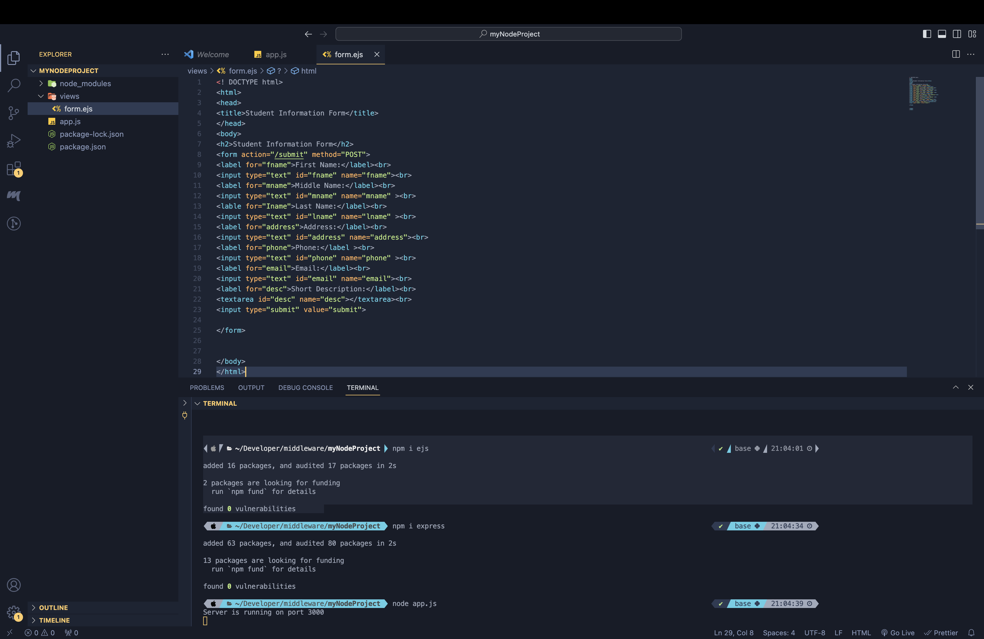

***Configuration for Handling Form Submissions:***

* ***Screenshot 6:****Visual Studio Code explorer or editor showcasing the added code in "app.js" to handle form submissions and parse incoming request bodies.*

***Execution of Node.js Web Application:***

* ***Screenshot 7:****Terminal window executing the command node app.js to run the Node.js application and display the server running on*[*http://localhost:3000.*](http://localhost:3000.)

